
MATHS METHODS (CAS) 3 & 4
TRIAL EXAMINATION 1
SOLUTIONS
2015

Question 1 (5 marks)

- 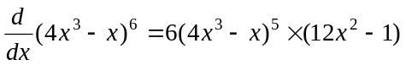 (Chain rule)
(1 mark) – 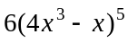
(1 mark) – 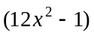

- 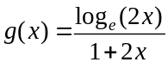
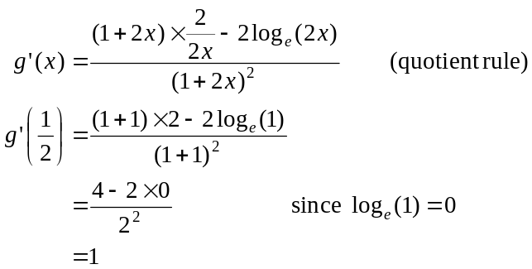
(1 mark) – correct numerator
(1 mark) – correct denominator
(1 mark)

Question 2 (2 marks)

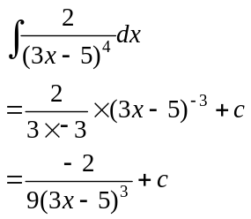
(1 mark) for 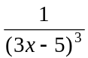
(1 mark) for 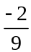

Question 3 (2 marks)

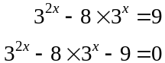

Let 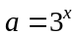
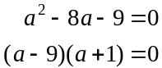
(1 mark)
Sub back
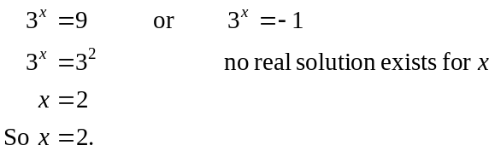
(1 mark)

Question 4 (2 marks)

Method 1
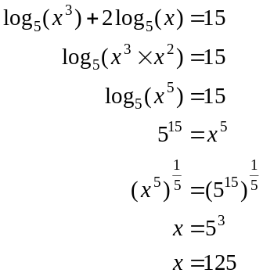
(1 mark)
(1 mark)
Method 2
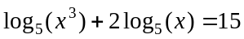
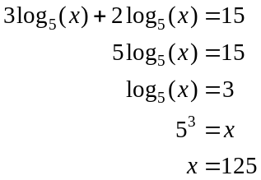
(1 mark)
(1 mark)

Question 5 (5 marks)

- 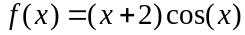
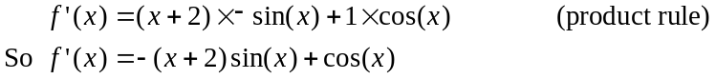
(1 mark) for first term
(1 mark) for second term
When 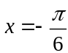,
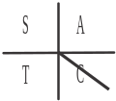
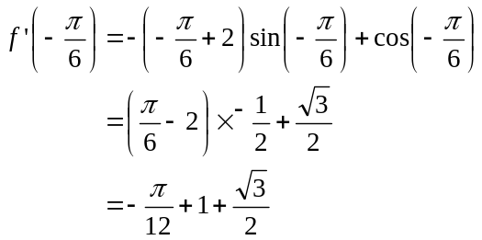
So the gradient of the graph at 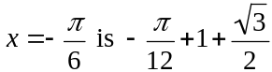.
(1 mark)
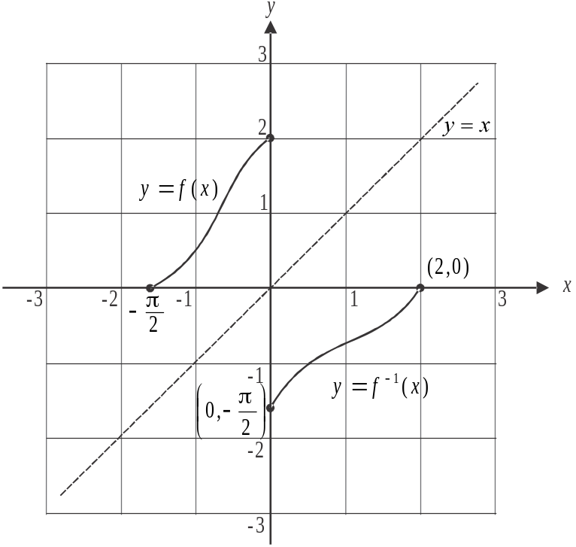

The graph of 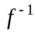 is a reflection of the graph of f in the line .
The endpoints of f are 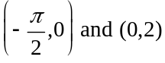.
The endpoints of are therefore 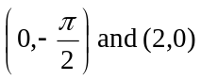.
(1 mark) – correct shape
(1 mark) – correct endpoints
Question 6 (3 marks)

Let 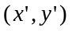 be an image point.
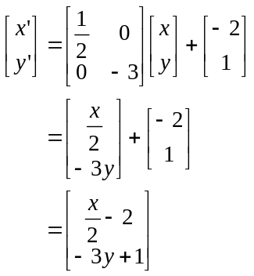
(1 mark)
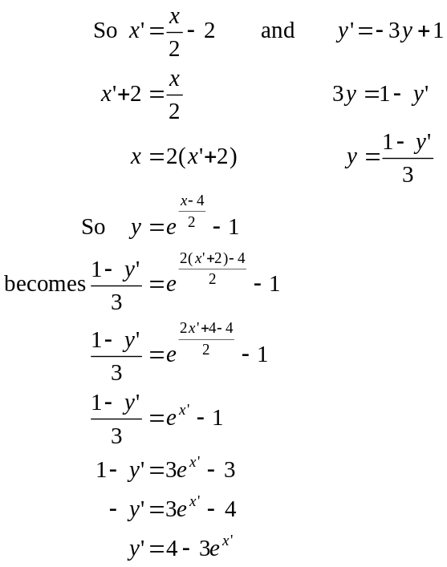
(1 mark)
The image equation is 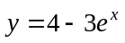.
So .
(1 mark)

Question 7 (5 marks)

- The graphs will intersect when

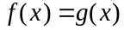
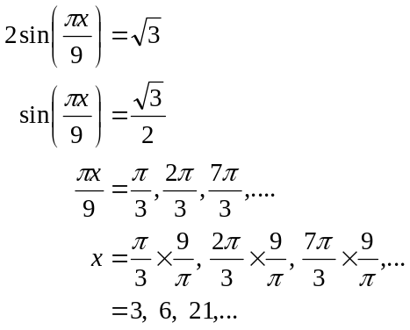
(1 mark)
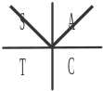
Since f and g are each defined for 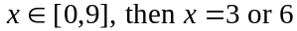.
Points of intersection are 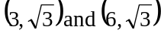.
(1 mark)

- Do a quick sketch.
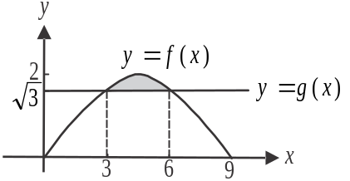
For the graph of 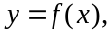
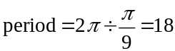
but 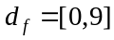.
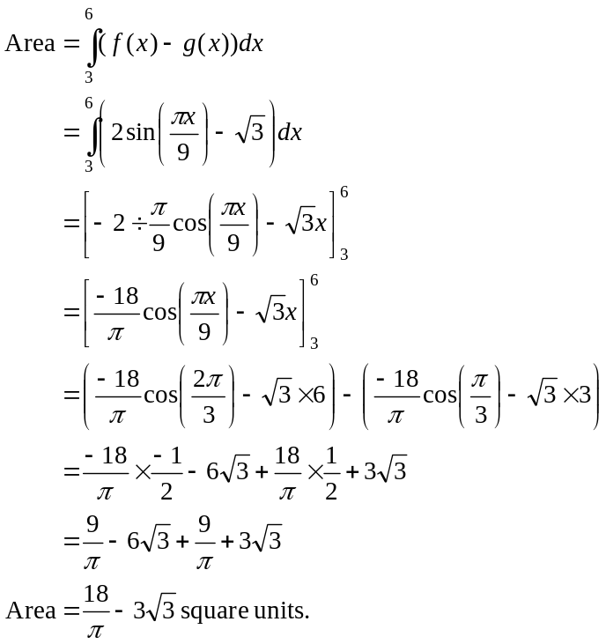
(1 mark)
(1 mark)
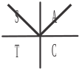
(1 mark)

Question 8 (4 marks)

- Since we have a probability density function,
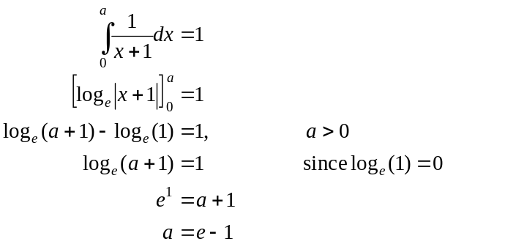
(1 mark)
(1 mark)

- 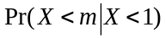
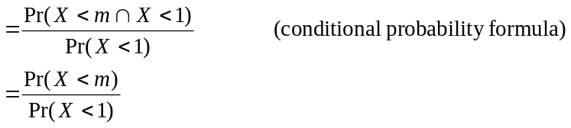
(1 mark)
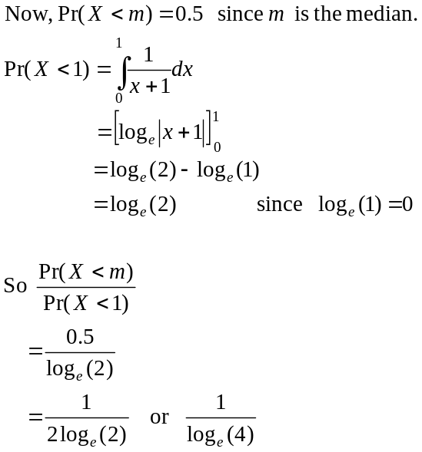
(1 mark)

Question 9 (6 marks)

- 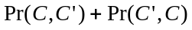 (1 mark)
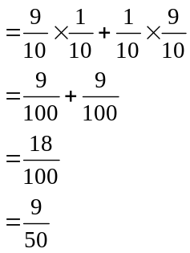
(1 mark)

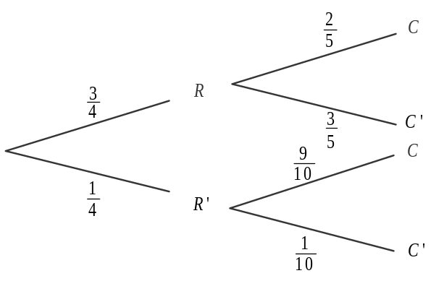
- i.

(1 mark)
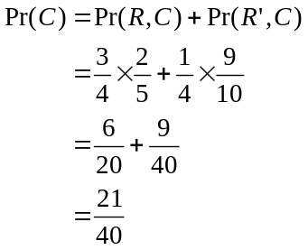
(1 mark)

- 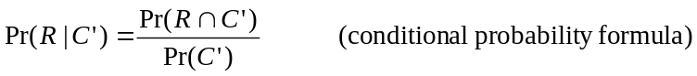 (1 mark)
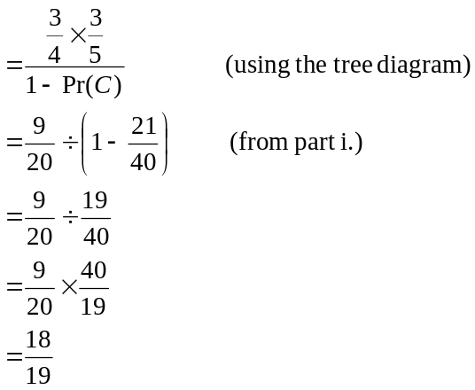
(1 mark)
Question 10 (6 marks)

- i. 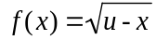
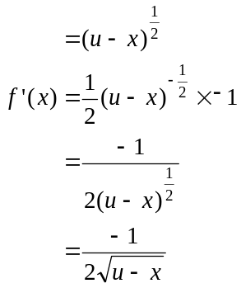

When the gradient of the tangent equals 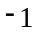,
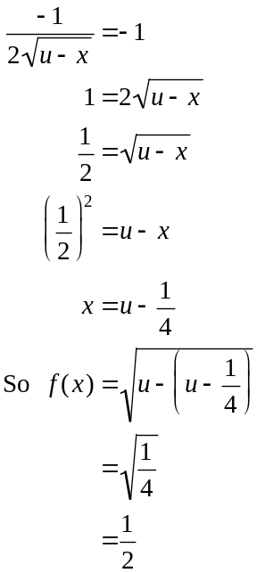
(1 mark)
The y-coordinate of P is when the gradient of the tangent is .
(1 mark)

- Method 1
Since the gradient of the tangent is , and
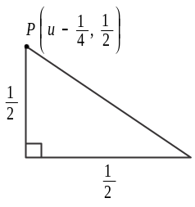
since the y coordinate of P is ,
then the horizontal distance will be unit.
(1 mark)
Method 2
Equation of tangent
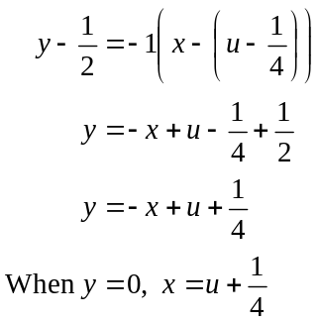
So the tangent intersects the x-axis at 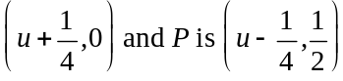.
So the horizontal distance is 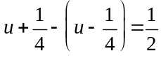 unit.
(1 mark)

- Let area of rectangle 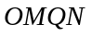 be A
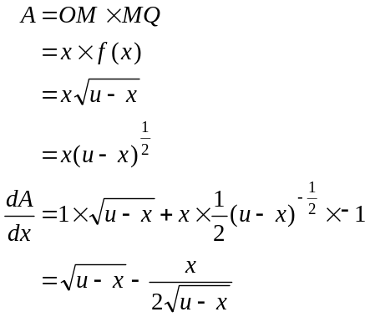
(1 mark)
Substitute 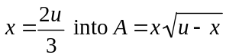
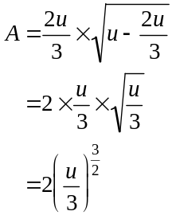
Maximum area is 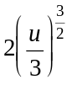 square units.
(1 mark)
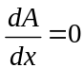 for max.
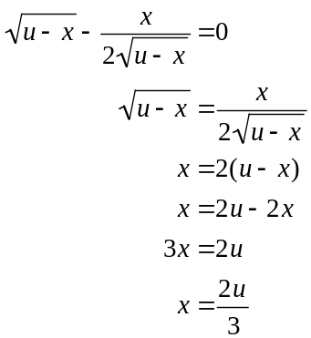
(1 mark)

